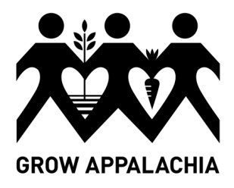
Grow Appalachia
Participant Application Appalachia-Science in the Public Interest

Grow Appalachia is a grant program dedicated to helping families plant a healthy future for themselves and their communities by:
- Providing them with skills and resources to grow sustainable, nutritious food.
- Teaching them how to prepare and preserve food in a healthy way.
- Empowering them to share their knowledge in the community.
- Creating programs to provide food to elderly and disabled residents in need.
- Supporting local farmers markets to sell surplus food.

Participants will be required to:
- provide a site for a vegetable garden (or take on a Community Garden plot)
- have the soil tested (at Grow Appalachia expense)
- attend minimum a of five trainings
- For home gardeners, participants will select (from summer internship schedule) one weekly education session in which participant will assist interns with hands-on learning of subject matter.
- For Community Gardeners, participants will attend the Community Garden work days
- record and return monthly harvest records,
- provide updates to Project Coordinator,
- volunteer five (5) hours of time to the Grow Appalachia Garden Project.

Applicant Name: ____________________________________________ # people in family: _____

Physical Address: ___________________________________________
___________________________________________
___________________________________________
Mailing Address (if different from above): ____________________________________
Telephone Number: ____________________________________
Email: _______________________________________________

Applicant signature: ________________________________________Date: ________________

Return completed application by April 15th, 2015 to ASPI office at:
50 Lair St. Mt. Vernon, KY 40456
Contact project coordinator if you have questions at: Ph: 606-256-0077

